**Introduction to jQuery**

**Lab report #04**



Fall 2023

CSE-423L Web Engineering

Submitted by: **Ashfaq Ahmad**

Registration No: **19PWCSE1795**

Class Section: **B**

“On my honor, as student of University of Engineering and Technology, I have neither given nor received unauthorized assistance on this academic work.”

Student Signature: ______________

Submitted to:

**Eng. Usman Malik**

**April** 02, 2023

**Department of Computer Systems Engineering**

**University of Engineering and Technology, Peshawar**

**Task 01:**

JavaScript is used to pre-compute the total cost of an order and display it to the customer

before the order is submitted to the server for processing.

Write a JavaScript code to calculate the Grand Total as shown below:

**HTML Code:**

<!DOCTYPE html>

<html lang="en">

<head>

    <meta charset="UTF-8">

    <meta http-equiv="X-UA-Compatible" content="IE=edge">

    <meta name="viewport" content="width=device-width, initial-scale=1.0">

    <title>Customer Bill</title>

    <link rel="stylesheet" href="Task01.css">

</head>

<body>

    <div class="bill">

        <table>

            <caption>Medical Billing System</caption>

            <tr>

                <th>S.No.</th>

                <th>Item</th>

                <th>Unit Cost (Rs.)</th>

                <th>Quantity</th>

                <th>Cost (Rs.)</th>

            </tr>

            <tr>

                <td>1</td>

                <td>Erithromycin 100mg</td>

                <td id="item1">58</td>

                <td><input type="text" id="q1" value=""></td>

                <td><input type="text" id="c1" value="0">

            </tr>

            <tr>

                <td>2</td>

                <td>Femramycin 500mg</td>

                <td id="item2">46</td>

                <td><input type="text" id="q2" value=""></td>

                <td><input type="text" id="c2" value="0"></td>

            </tr>

            <tr>

                <td>3</td>

                <td>Oxiymclin 2mg</td>

                <td id="item3">1090</td>

                <td><input type="text" id="q3" value=""></td>

                <td><input type="text" id="c3" value="0"></td>

            </tr>

            <tr>

                <td colspan="4" style="text-align: end; font-weight: bold;">Total</td>

                <td><input type="text" id="tt" value=""></td>

            </tr>

            <tr>

                <td colspan="4" style="text-align: end; font-weight: bold;">GST at 15%</td>

                <td><input type="text" id="percent" value=""></td>

            </tr>

            <tr>

                <td colspan="4" style="text-align: end; font-weight: bold;">Grand Total Rs.</td>

                <td><input type="text" id="gtt" value=""></td>

            </tr>

            <tr>

                <td colspan="3" style="text-align: end;"><button>Update Grand Total</button></td>

            </tr>

        </table>

    </div>

    <script src="Task01.js"> </script>

</body>

</html>

**CSS Code:**

.bill{

    width: 34%;

    border: 3px solid;

    padding: 40px 5px;

}

table{

    background-color: rgb(251, 251, 223);

}

caption{

    color: green;

    font-weight: bold;

}

th{

    background-color: rgb(225, 244, 255);

    padding: 20px 5px;

}

td{

    text-align: center;

    padding: 5px 0px;

}

input{

    width: 38px;

}

button{

    background-color: rgb(252, 233, 236);

    font-weight: bolder;

    color: red;

    border-color: rgb(252, 233, 236);

    padding: 5px 3px;

}

**JavaScript Code:**

const item1 = document.getElementById('item1');

        const item2 = document.getElementById('item2');

        const item3 = document.getElementById('item3');

        const q1 = document.getElementById('q1');

        const q2 = document.getElementById('q2');

        const q3 = document.getElementById('q3');

        const c1 = document.getElementById('c1');

        const c2 = document.getElementById('c2');

        const c3 = document.getElementById('c3');

        const total = document.getElementById('tt');

        const percent = document.getElementById('percent');

        const grandtotal = document.getElementById('gtt');

        q1.addEventListener('input', calculate1);

        function calculate1() {

            const unitPrice = parseInt(item1.innerHTML);

            const quantity = parseInt(q1.value);

            const totalCost=unitPrice * quantity;

            c1.value = totalCost;

            finalCost();

        }

        q2.addEventListener('input', calculate2);

        function calculate2() {

            const unitPrice = parseInt(item2.innerHTML);

            const quantity = parseInt(q2.value);

            const totalCost=unitPrice * quantity;

            c2.value = totalCost;

            finalCost();

        }

        q3.addEventListener('input', calculate3);

        function calculate3() {

            const unitPrice = parseInt(item3.innerHTML);

            const quantity = parseInt(q3.value);

            const totalCost=unitPrice * quantity;

            c3.value = totalCost;

            finalCost();

        }

        function finalCost(){

            const totalprice=parseInt(c1.value) + parseInt(c2.value) + parseInt(c3.value);

            total.value=totalprice;

            const gst=(totalprice/100)*15;

            percent.value=gst;

            const fc=totalprice + gst;

            grandtotal.value=fc;

        }

**Result:**

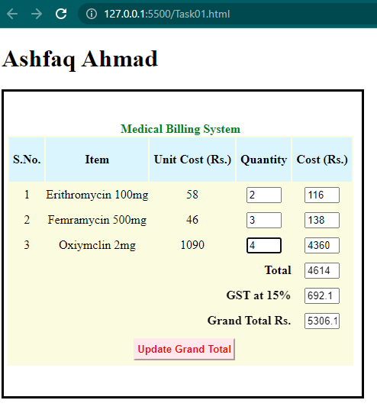

**Task 02:**

Use jQuery to write a code that will change all the occurrences of “White” with the color

specified in the text input field by clicking the “Change” button.

**HTML Code:**

<!DOCTYPE html>

<html lang="en">

<head>

    <meta charset="UTF-8">

    <meta http-equiv="X-UA-Compatible" content="IE=edge">

    <meta name="viewport" content="width=device-width, initial-scale=1.0">

    <title>Color changing</title>

    <link rel="stylesheet" href="Task02.css">

    <script src="https://ajax.googleapis.com/ajax/libs/jquery/3.6.3/jquery.min.js"></script>

</head>

<body>

    <div id="cntr" class="container">

        <h1>White Color is Who's favourite!!!!</h1>

        <br>

        <p>

            <b> White</b> is a color often associated with purity, innocence, and cleanliness. it is the color of fresh snow, a black canvas, and a pristine wedding dress. In some cultures, <b> White</b> is an associated with morning and is worn a funerals. In desing and fashion, <b>White</b> is often used to create a sense of simplicity, elegance, and modernity. <b>White</b>  is a verstile color that can evoke a verity of emotions and meaning, depending on text in which it is used.

        </p>

        <br>

        <label for="color">Change the color to:</label>

        <input type="text" name="color" id="colorname">

        <button id="btn">Change!</button>

    </div>

    <script src="Task02.js"></script>

</body>

</html>

**CSS Code:**

.container{

    background-color: rgb(247, 244, 244);

    width: 50%;

}

input,button{

    padding: 8px 0px;

    margin: 0px 3px;

}

button{

    background-color: rgb(217, 213, 213);

    border-color: rgb(217, 213, 213);

}

**jQuery Code:**

$(document).ready(function () {

    $('#btn').click(function () {

        $('b').css('color', $('#colorname').val())

    })

})

**Result:**

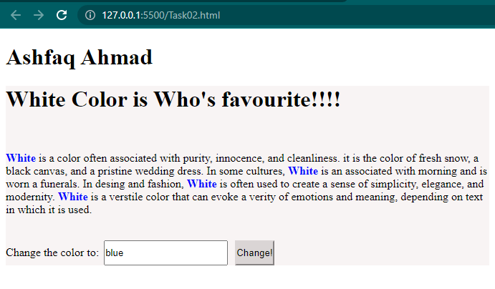 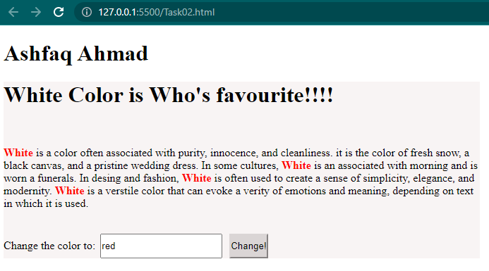

**Task 03:**

Create an Html form as shown below, Use jQuery to perform the following functions:

* When the page is loaded, cities will not display.
* When the user selects the country Pakistan, all cities of Pakistan will show only.
* When the user selects any other country than Pakistan, a field is shown to enter the city name manually.

**HTML Code:**

<!DOCTYPE html>

<html lang="en">

<head>

    <meta charset="UTF-8">

    <meta http-equiv="X-UA-Compatible" content="IE=edge">

    <meta name="viewport" content="width=device-width, initial-scale=1.0">

    <title>form</title>

    <link rel="stylesheet" href="Task03.css">

    <script src="https://ajax.googleapis.com/ajax/libs/jquery/3.6.3/jquery.min.js"></script>

</head>

<body>

    <form>

        <h3>Student Form</h3>

        <div>

            <label for="name">Name:</label>

            <input type="text" id="name" placeholder="Enter your name">

        </div>

        <div>

            <label for="pswd">Password:</label>

            <input type="password" id="pswd" placeholder="Password">

        </div>

        <div>

            <label for="selection">Country:</label>

            <select id="selection">

                <option value="Select">Select</option>

                <option value="Afghanistan">Afghanistan</option>

                <option value="Bangladash">Bangladash</option>

                <option value="Pakistan">Pakistan</option>

            </select>

        </div>

        <div id="city-select">

            <label for="city">Cities:</label>

            <select id="city" name="city">

                <option value="">Select a city</option>

                <option value="karachi">Karachi</option>

                <option value="lahore">Lahore</option>

                <option value="islamabad">Islamabad</option>

            </select>

        </div>

        <div id="city-input">

            <label for="city-manual">City:</label>

            <input type="text" id="city-manual" placeholder="Enter your city name">

        </div>

        <div>

            <label for="txt">Message:</label>

            <textarea id="txt" cols="30" rows="10"></textarea>

        </div>

        <div>

            <label for="upload">Upload Pic:</label>

            <input type="file" id="upload">

        </div>

        <button id="btn">sign Up</button>

    </form>

    <script src="Task03.js"></script>

</body>

</html>

**CSS Code:**

form{

    width: 400px;

    text-align: center;

}

input,select,textarea{

    width: 200px;

    margin: 10px 5px;

    padding: 5px 0px;

}

#btn{

    background-color: dodgerblue;

    border-color:dodgerblue ;

    color: white;

    border-radius: 4px;

    padding: 5px 10px;

    margin: 10px 0px;

}

div:nth-last-child(even){

    background-color: rgb(232, 229, 229);

}

**jQuery Code:**

$(document).ready(function(){

    $('#city-select').hide();

    $('#city-input').hide();

    $('#selection').change(function(){

        if($(this).val()==='Pakistan'){

            $('#city-select').show();

            $('#city-input').hide();

        }else{

            $('#city-select').hide();

            $('#city-input').show();

        }

    })

})

**Result:**

**(Pakistan selection)**

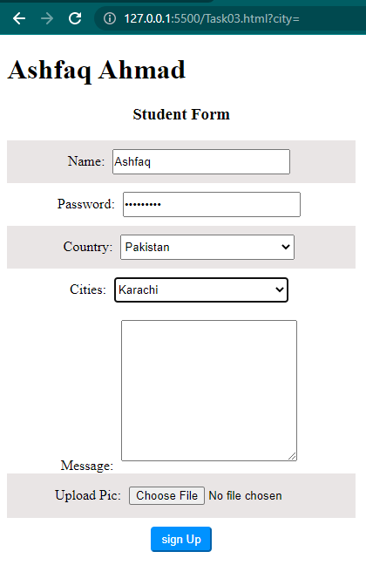

**(Other Country selection)**

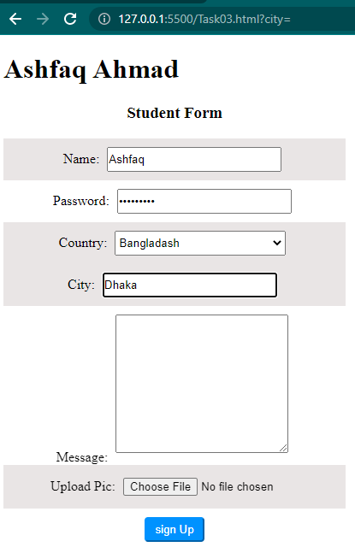

**Task 04:**

Use jQuery .css(), .hasClass(), .removeClass(), .addclass(), .toggleClass(). .addClass(),

.attr(), .append(). Achieve the output as shown below:

**HTML Code:**

<!DOCTYPE html>

<html lang="en">

<head>

    <meta charset="UTF-8">

    <meta http-equiv="X-UA-Compatible" content="IE=edge">

    <meta name="viewport" content="width=device-width, initial-scale=1.0">

    <title>Task04</title>

    <link rel="stylesheet" href="Task04.css">

    <script src="https://ajax.googleapis.com/ajax/libs/jquery/3.6.3/jquery.min.js"></script>

</head>

<body>

    <h1>Ashfaq Ahmad</h1>

    <div class="container">

        <div class="box1 box"></div>

        <div class="box2 box"></div>

        <div class="box3 box"></div>

    </div>

    <h1>Toggles</h1>

    <button class="btn1">Toggle Colors</button>

    <button class="btn2">Toggle Rounded Borders</button>

    <button class="btn3">Add a new box</button>

    <br>

    <h1>Descriptions</h1>

    <ul>

        <li>Toggle Colors: Toggles the colors on and off for each box using css classes</li>

        <li>Toggle Rounded Borders: Toggles the Rounded Borders on and off for each box using css attributes</li>

        <li>Add a new box: Add one new box to container</li>

    </ul>

    <script src="Task04.js"></script>

</body>

</html>

**CSS Code:**

.container{

    display: flex;

}

.box1,.box2,.box3{

    width: 100px;

    height: 100px;

    border: 1px solid;

}

.toggle{

    background-color: green;

}

.border{

    border-radius: 30px;

}

.addbox{

    width: 100px;

    height: 100px;

    border: 1px solid;

}

**JavaScript Code:**

$(document).ready(function(){

    $('.btn1').click(function(){

        $('.box').toggleClass('toggle');

    })

    $('.btn2').click(function(){

        $('.box').toggleClass('border');

    })

    $('.btn3').click(function(){

        $('.container').append('<div class=\'box3 box\'></div>');

    })

})

**Result:**

